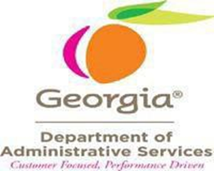

Modified Vehicle Ordering Process Instructions
Requirements to Know:
- Effective Date: July 11, 2022
- This process change will remain in effect until the State Purchasing Division determines the change is no longer needed.
- State Entities are required to utilize the mandatory statewide contract to purchase vehicles. Awarded suppliers within each vehicle class/category must be used to purchase the vehicle desired by the Entity.
- The Modified Vehicle Ordering Process Form is used to request/grant approval from DOAS to utilize the Modified Vehicle Ordering process for the purchase of vehicles ordered from the approved dealers on the Administrative Vehicles Statewide Contract, including those not awarded for that line item or category.
  - For example, a requesting entity may get a quote for the Chevrolet Tahoe from Allan Vigil Ford even though they did not bid on that vehicle.
- Authorized Users must comply with all applicable laws and regulations.
- This process does not require a waiver, as a requirement of utilizing this process.
- This process does not allow for purchases of vehicles not awarded as a line item on the statewide contract
  - i.e., Jeep Patriot
- The quoted price from the supplier must be fair and reasonable.
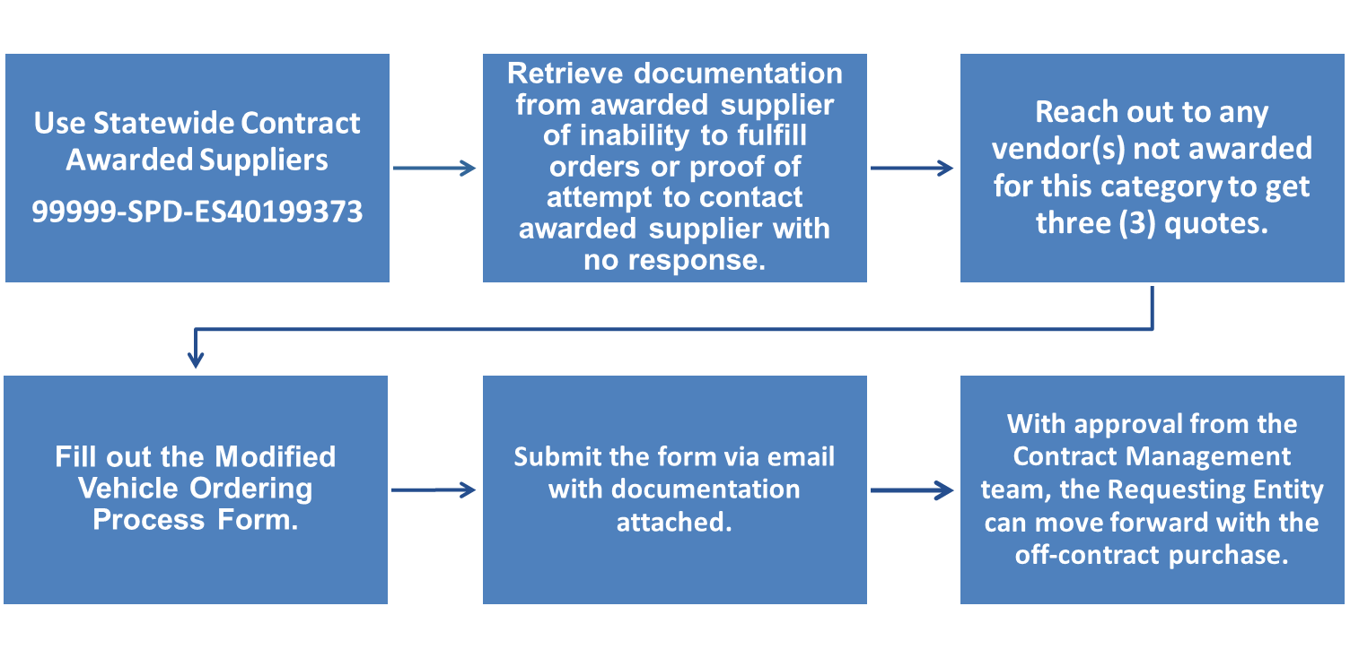
- New vehicles selected from non-awarded suppliers using this form may be ordered OR on-lot vehicles.

- Retrieve documentation from the awarded supplier of inability to fulfill orders or proof of attempt to contact awarded supplier with no response.
  - Suppliers in the awarded vehicle class/category have up to five (5) business days to commit in writing their ability to fulfill orders received by Entity. If the awarded supplier cannot commit to fulfill orders received by the Entity Buyer within five (5) business days, the Entity Buyer provide proof of reasonable efforts (at least two emails) to reach supplier without hearing back or confirmation from the awarded supplier of inability to fulfill the order.
  - Required documentation must be provided as an email attachment sent with the request to the Contract Management Team.

- Reach out to any vendor(s) not awarded for this category to get a quote.
  - The Entity must reach out to at least three (3) statewide contract vehicle suppliers to determine if they have available inventory to meet Entity needs and must provide these quotes on Page 2 of the MVOP form.
    - If there are less than three (3) suppliers that can provide a quote, the requesting entity provides documentation of the non-awarded supplier(s) confirming they are unable to supply or documentation of efforts to get in contact with suppliers for a quote.
  - The vehicle statewide contract suppliers can choose to respond to Entity request and offer to provide a vehicle at either the current awarded SWC price or provide their best available price.
  - A list of awarded and non-awarded statewide contract suppliers by vehicle class/category is included on the Modified Vehicle Ordering Process Form.

- Filling out the Modified Vehicle Ordering Process Form
- On Page 2 of the form, provide the 3 quotes from awarded contract suppliers and justification to support the request to utilize the MVOP:
  - Time: The choice can be based off availability of when the supplier could provide the vehicle if that is what the requesting entity needs, and the price is reasonable.
  - Price: The requesting entity can choose the best quoted value available.
    - Note: This form does not grant permission for buyers to choose a different supplier that can sell the vehicle cheaper if the awarded supplier can provide.

- Submit the form via email with documentation attached.
  - Form must be emailed to Emily Harris at emily.harris@doas.ga.gov and contract.management@doas.ga.gov
  - A request must include the following:
    - Proof that the supplier in the awarded vehicle class/category was contacted and provided an opportunity (5 business days) to respond with reasonable efforts to get in touch with them OR
    - Documentation from the awarded supplier indicating they could not fulfill the order.
  - At least 3 quotes from contract suppliers not awarded that line item and justification of the agency’s choice of which supplier to purchase the vehicle from if approved.
  - You will receive approval within three (3) business days to purchase the selected quoted vehicle from the supplier not awarded for that vehicle on contract.
  - Terms of Approval: Requestor has been granted approval to use the Modified Vehicle Ordering Process when the form has been returned with a signature from the contract management team.

- With approval from the Contract Management team, the Requesting Entity can move forward with the off-contract purchase.
  - The requesting entity will have approval when the MVOP form has been returned with a signature from the contract management team.
  - Provide the signed form to the Office of Fleet Management (OFM) when completing your purchase.
  - Be sure to follow all OFM’s policies and procedures.
    - Please reach out to Bobby Arrington at bobby.arrington@doas.ga.gov if you have any questions for the OFM.

